CONTENT MANAGER
PROJECT DOCUMENTATION
Introduction
Project Title: Contact Manager
Team ID: SWTID-2026-1084
Team Size: 4
Team Leader:
DEEPAK SINGH S(sdeepaksingh3005@gmail.com)
Team Members:
KABILAN V (kabikabi2602@gmail.com )
GOWTHAM J(gowtham26012007@gmail.com )
KAVI S(kaviselvarajmbbs@gmail.com )
🏁 Phase 1: Quality Assurance (The "Final Polish")
Before you call it 100% done, the team should perform a final check to ensure the "Contact Manager" actually works as intended.
- Bug Bash: Have Kabilan and Gowtham try to "break" the app. What happens if you add a contact with no name? What if you enter a 20-digit phone number?
- Code Review: Deepak (as Leader) should review the code for readability. Remove any console.log statements or "TODO" comments.
- Responsive Check: Ensure the UI looks good on both a laptop screen and a mobile phone.
📄 Phase 2: Documentation (The "Paperwork")
Great code is invisible without great documentation. Kavi can lead this effort:
- README File: Create a README.md in your GitHub repository. It should include:
  - Project Title & Team ID: (SWTID-2026-1084).
  - Installation Instructions: How can someone else run your code?
  - Tech Stack: Mention if you used HTML/JS, React, Python, or SQL.
- Project Report: A PDF document summarizing:
  - Problem Statement: Why is a contact manager needed?
  - Features: List the completed tasks (e.g., search, delete, edit).
  - System Architecture: A simple diagram showing how the Frontend, Backend, and Database talk to each other.
📦 Phase 3: Final Submission & Presentation
This is how you hand over the project to your evaluators or clients.
Task | Responsible | Description
Video Demo | Deepak | Record a 8–10 minute screen recording of the app in action.
Presentation Slides | All | Prepare 5–6 slides (Introduction, Tech Stack, Features, Challenges Faced, Conclusion).
Source Code | Deepak | Zip the project folder or provide the GitHub link. Ensure you exclude node_modules to keep the file size small!
Team Declaration | All | A signed document stating that all 4 members contributed to the project.

Connect Hub

PROJECT OVERVIEW
The ConnectHub is a backend web application designed to solve the common problem of scattered contact information across multiple platforms. It provides users with a centralized, organized system to store, search, and categorize their professional and personal contacts.

Key Objectives:
• Provide secure user authentication and data isolation
• Enable efficient contact management through CRUD operations
• Implement flexible categorization using tags
• Offer fast search and filtering capabilities
• Deliver a responsive, cross-device user experience

Target Users:
• Freelancers and consultants managing client relationships
• Small business owners tracking vendor and customer contacts
• Students and young professionals building their network
• Event organizers managing attendee and volunteer information
• Anyone seeking a simple, privacy-focused contact management solution

1️⃣ Create Project Folder
Open terminal.
mkdir connecthub
cd connecthub
mkdir server
cd server

2️⃣ Initialize Node Project
npm init -y

3️⃣ Install Dependencies
npm install express mongoose cors dotenv bcryptjs jsonwebtoken
npm install nodemon --save-dev

4️⃣ Update package.json
Add type module and dev script
{
"name": "connecthub",
"version": "1.0.0",
"type": "module",
"scripts": {
"dev": "nodemon server.js"
}
}

5️⃣ Create Project Structure
Inside server folder
server
│
├── config
│ └── db.js
│
├── models
│ ├── User.js
│ └── Contact.js
│
├── controllers
│ ├── authController.js
│ └── contactController.js
│
├── routes
│ ├── authRoutes.js
│ └── contactRoutes.js
│
├── middleware
│ └── authMiddleware.js
│
├── .env
└── server.js

6️⃣ Environment Variables
Create .env
PORT=5000
MONGO_URI=mongodb://127.0.0.1:27017/connecthub
JWT_SECRET=mysecretkey
Make sure MongoDB is running.

7️⃣ Database Connection
📄 config/db.js
import mongoose from "mongoose";
const connectDB = async () => {
try {
await mongoose.connect(process.env.MONGO_URI);
console.log("MongoDB Connected");
} catch (error) {
console.log(error);
process.exit(1);
}
};
export default connectDB;

8️⃣ User Model
📄 models/User.js
import mongoose from "mongoose";
const userSchema = new mongoose.Schema(
{
name: { type: String, required: true },
email: { type: String, required: true, unique: true },
password: { type: String, required: true }
},
{ timestamps: true }
);
export default mongoose.model("User", userSchema);

9️⃣ Contact Model
📄 models/Contact.js
import mongoose from "mongoose";
const contactSchema = new mongoose.Schema(
{
userId: {
type: mongoose.Schema.Types.ObjectId,
ref: "User",
required: true
},
name: { type: String, required: true },
email: String,
phone: String,
notes: String,
tags: [String]
},
{ timestamps: true }
);
export default mongoose.model("Contact", contactSchema);

🔟 Authentication Controller
📄 controllers/authController.js
import User from "../models/User.js";
import bcrypt from "bcryptjs";
import jwt from "jsonwebtoken";
export const register = async (req, res) => {
try {
const { name, email, password } = req.body;
const userExists = await User.findOne({ email });
if (userExists) {
return res.status(400).json({ message: "User already exists" });
}
const salt = await bcrypt.genSalt(10);
const hashedPassword = await bcrypt.hash(password, salt);
const user = await User.create({
name,
email,
password: hashedPassword
});
res.status(201).json({ message: "User Registered" });
} catch (error) {
res.status(500).json({ message: error.message });
}
};
export const login = async (req, res) => {
try {
const { email, password } = req.body;
const user = await User.findOne({ email });
if (!user) {
return res.status(400).json({ message: "Invalid credentials" });
}
const isMatch = await bcrypt.compare(password, user.password);
if (!isMatch) {
return res.status(400).json({ message: "Invalid credentials" });
}
const token = jwt.sign(
{ id: user._id },
process.env.JWT_SECRET,
{ expiresIn: "1d" }
);
res.json({ token });
} catch (error) {
res.status(500).json({ message: error.message });
}
};

1️⃣1️⃣ Authentication Middleware
📄 middleware/authMiddleware.js
import jwt from "jsonwebtoken";
const authMiddleware = (req, res, next) => {
const authHeader = req.headers.authorization;
if (!authHeader) {
return res.status(401).json({ message: "No token provided" });
}
const token = authHeader.split(" ")[1];
try {
const decoded = jwt.verify(token, process.env.JWT_SECRET);
req.userId = decoded.id;
next();
} catch (error) {
res.status(401).json({ message: "Invalid token" });
}
};
export default authMiddleware;

1️⃣2️⃣ Contact Controller
📄 controllers/contactController.js
import Contact from "../models/Contact.js";
export const createContact = async (req, res) => {
try {
const contact = await Contact.create({
...req.body,
userId: req.userId
});
res.status(201).json(contact);
} catch (error) {
res.status(500).json({ message: error.message });
}
};
export const getContacts = async (req, res) => {
const contacts = await Contact.find({ userId: req.userId });
res.json(contacts);
};
export const updateContact = async (req, res) => {
const contact = await Contact.findByIdAndUpdate(
req.params.id,
req.body,
{ new: true }
);
res.json(contact);
};
export const deleteContact = async (req, res) => {
await Contact.findByIdAndDelete(req.params.id);
res.json({ message: "Contact deleted" });
};

1️⃣3️⃣ Routes
📄 routes/authRoutes.js
import express from "express";
import { register, login } from "../controllers/authController.js";
const router = express.Router();
router.post("/register", register);
router.post("/login", login);
export default router;

📄 routes/contactRoutes.js
import express from "express";
import authMiddleware from "../middleware/authMiddleware.js";
import {
createContact,
getContacts,
updateContact,
deleteContact
} from "../controllers/contactController.js";
const router = express.Router();
router.post("/", authMiddleware, createContact);
router.get("/", authMiddleware, getContacts);
router.put("/:id", authMiddleware, updateContact);
router.delete("/:id", authMiddleware, deleteContact);
export default router;

1️⃣4️⃣ Main Server
📄 server.js
import express from "express";
import cors from "cors";
import dotenv from "dotenv";
import connectDB from "./config/db.js";
import authRoutes from "./routes/authRoutes.js";
import contactRoutes from "./routes/contactRoutes.js";
dotenv.config();
const app = express();
connectDB();
app.use(cors());
app.use(express.json());
app.use("/api/auth", authRoutes);
app.use("/api/contacts", contactRoutes);
app.get("/", (req, res) => {
res.send("Backend is running");
});
const PORT = process.env.PORT || 5000;
app.listen(PORT, () => {
console.log(`Server running on port ${PORT}`);
});

1️⃣5️⃣ Start Server
npm run dev
You should see:
MongoDB Connected
Server running on port 5000

1️⃣6️⃣ Test APIs
Register
POST
http://localhost:5000/api/auth/register
Body
{
"name":"John",
"email":"john@gmail.com",
"password":"123456"
}

Login
POST /api/auth/login
Copy the token.

Create Contact
POST /api/contacts
Header
Authorization: Bearer TOKEN
Body
{
"name":"Alex",
"email":"alex@gmail.com",
"phone":"9999999999",
"notes":"client",
"tags":["work"]
}

Pre-requirements

Software Requirements
Software | Purpose
Node.js | JavaScript runtime for backend
MongoDB | NoSQL database for data storage
npm | Package manager
Git | Version control system
Code Editor | VS Code, WebStorm, or similar

Knowledge Requirements
• JavaScript ES6+ syntax and concepts
• Node.js and Express.js for RESTful API development
• MongoDB and Mongoose ODM
• JWT authentication and bcrypt password hashing
• Git version control workflow

PROJECT THUMBNAIL
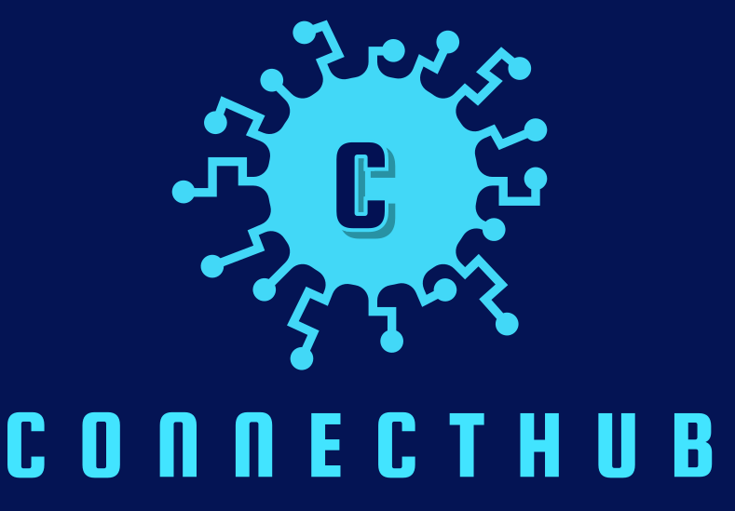

PROJECT ARCHITECTURE

High-level architecture diagram illustrating the three-tier backend structure.
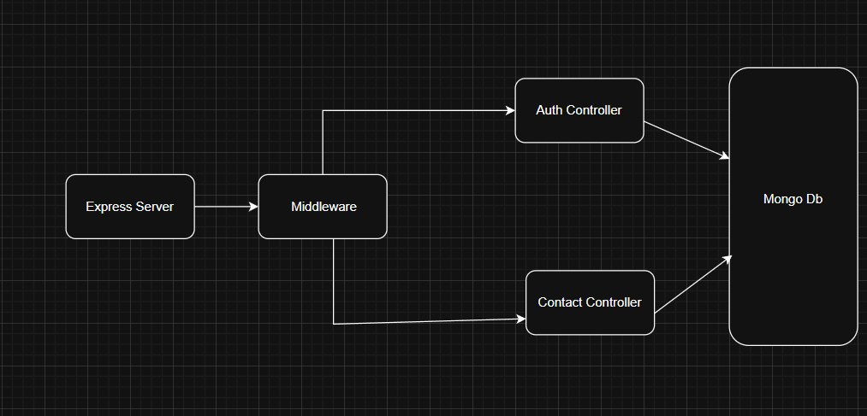

Node.js + Express Backend
• RESTful API architecture
• JWT authentication middleware
• MVC pattern (Models, Controllers, Routes)
• Input validation and error handling

MongoDB Database
• Document-based NoSQL storage
• Mongoose ODM for schema modeling
• Two collections: Users and Contacts
• Indexed fields for optimized queries

Techinical Arichitecture

Backend Architecture (Node.js + Express)
• Controllers: Business logic for authentication and CRUD operations
• Models: Mongoose schemas defining data structure
• Routes: API endpoint definitions with HTTP methods
• Middleware: JWT verification, error handling, validation
• Configuration: Database connection and environment variables

Database Architecture (MongoDB)
• Users Collection: _id, name, email, password (hashed), timestamps
• Contacts Collection: _id, userId (FK), name, email, phone, notes, tags[], timestamps
• Relationships: Many-to-One (Contacts → User)
• Indexes: email (unique), userId, name, tags (for search)

ER Diagram

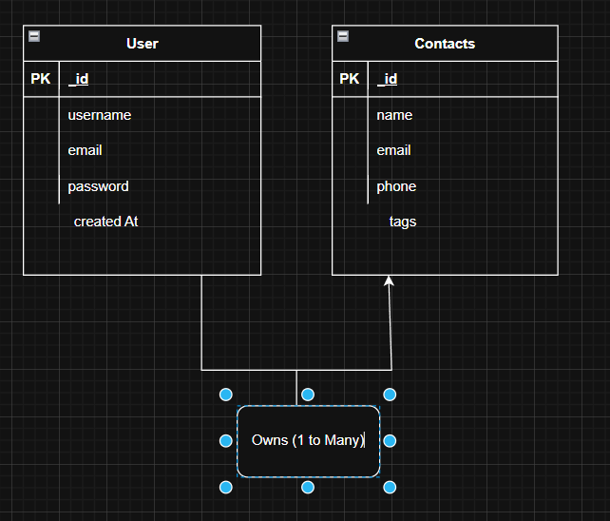

Features

Core Features

# | Feature | Description
1 | User Authentication | JWT-based registration, login, and session management with bcrypt password hashing
2 | Contact CRUD | Create, read, update, and delete contacts with full validation and error handling
3 | Tag Categorization | Organize contacts with multiple tags (Work, Family, Friends, etc.) and filter by category
4 | Real-time Search | Debounced search across name, email, and tags with instant results
Roles and Responsibility

- User -

- Registration - Register on the application using the name, email , password
- Login - Login on the application using the email and registered password
- Search - Search for a contact using name , email or tags
- Add Contact - Add new contact - name , email , phone , notes , tags
- Edit Contact - Edit the existing contact
- Delete Contact - Delete any contact

User Flow

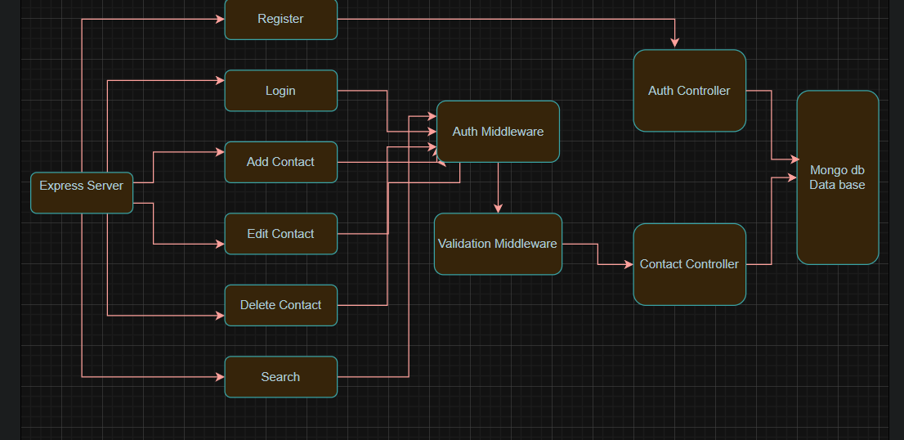

Project Setup and Configuration

Folder Structure

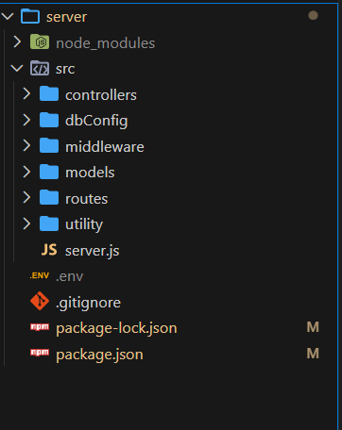

Project Setup

1. Install required tools and software:
• Node.js.
• MongoDB.
2. Create project folders and files:
• Server folders.
3. Install Packages:
Backend npm Packages
• Express.
• Mongoose.
• Cors.

Backend Development
• Setup express server
• Create index.js file in the server (backend folder).
• Create a .env file and define port number to access it globally.
• Configure the server by adding cors, body-parser.

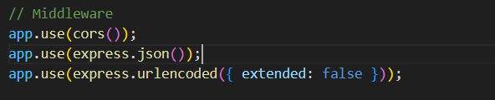
• User Authentication:
• Create routes and middleware for user registration, login, and
• Set up authentication middleware to protect routes that require user authentication.

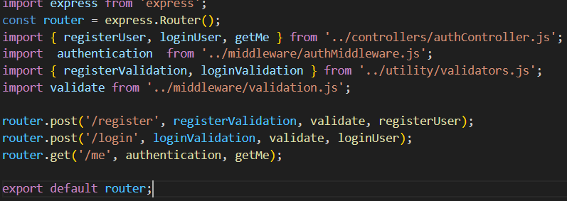

• Define API Routes:
• Create separate route files for different API functionalities such as user authentication and crud operation for contacts
• Implement route handlers using Express.js to handle requests and interact with the database.

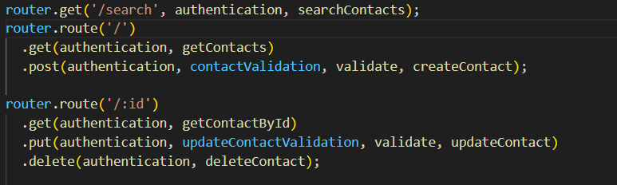

• Implement Data Models:
• Define Mongoose schemas for the different data entities like user and contact
• Create corresponding Mongoose models to interact with the MongoDB database.
• Implement CRUD operations (Create, Read, Update, Delete) for each model to perform databaseoperations. 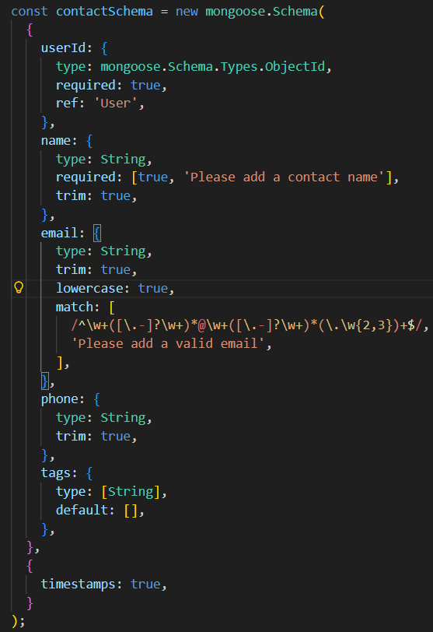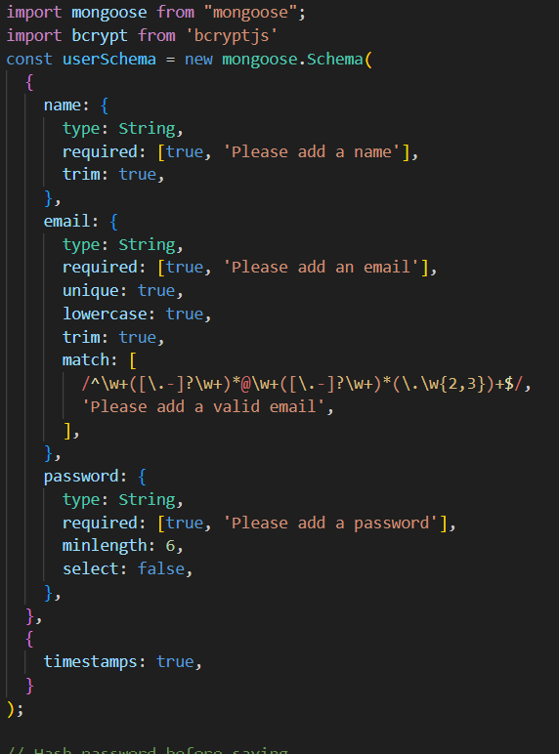
• Error Handling:
• Implement error handling middleware to catch and handle any errors that occur during the API requests.
• Return appropriate error responses with relevant error messages and HTTP status codes.

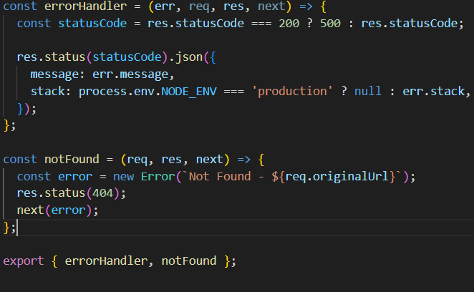

Database Configuration and Setup
1. Configure MongoDB:
• Install Mongoose.
• Create database connection.
• Create Schemas & Models.

2. Connect database to backend:
Now, make sure the database is connected before performing any of the actions through the backend. The connection code looks similar to the one provided below.

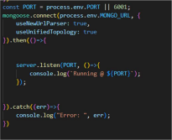

3. Configure Schema:
Firstly, configure the Schemas for MongoDB database, to store the data in such pattern. Use the data from the ER diagrams to create the schemas.
The schemas are looks like for the Application.
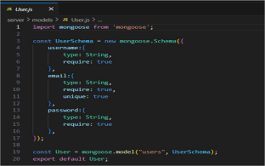

Project Execution

Execution Steps
- Open the project folder in the terminal
- Make sure you have a start script in the package.js file
- Use the command npm start to start the server
- You will the Running on PORT message on the successfully starting the server
- You will also see the database connected message if the database is connected successfully
- Use the Thunder client or Postman for using the created api’s

Output Screenshots
- Register Api
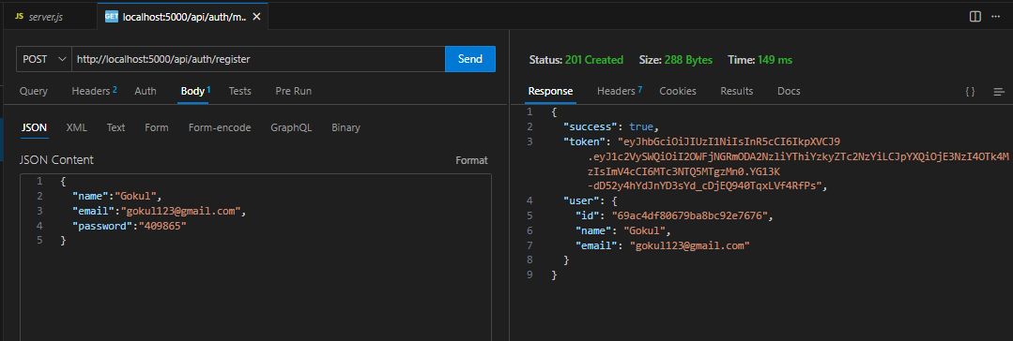

- Login Api

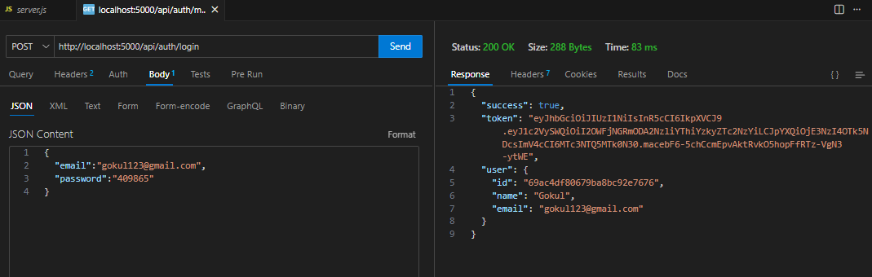

- Create New Contact
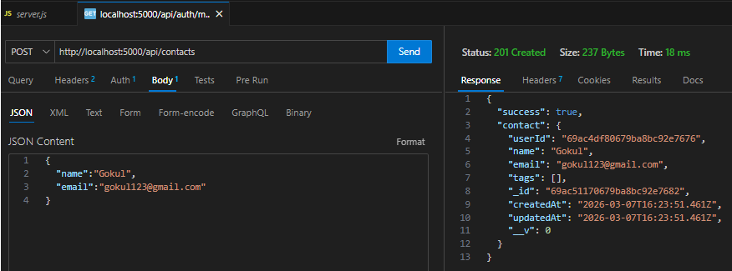

- Update Contact
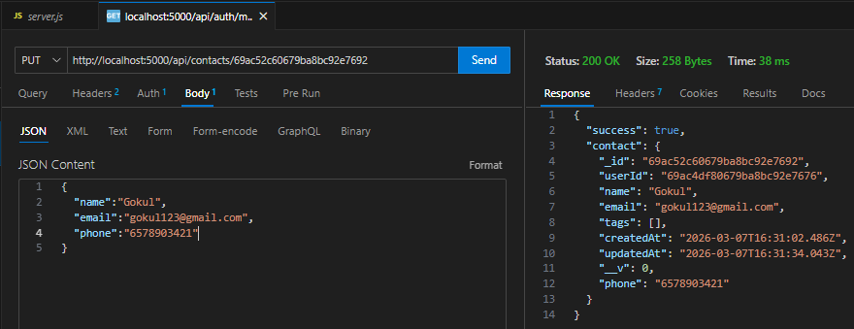

- Delete Contact
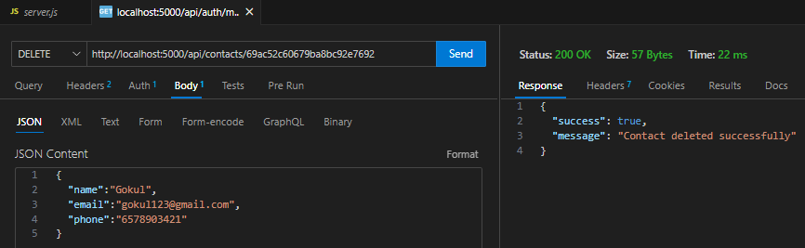

- Search Contact
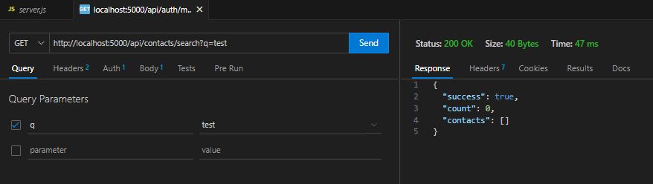

- Get The Current User
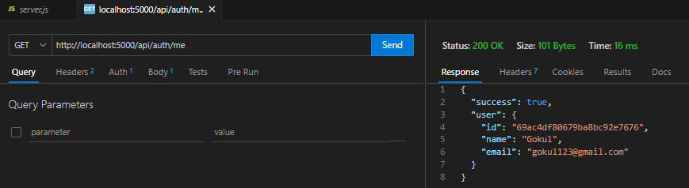

Project Demo

Contact Manager.webm

Code Link

Contact-Manager

